HOW I MADE THE CIRCUITS

Experiment 1: Verifying Kirchhoff’s Current Law (KCL)
How I Built the Circuit: For the first experiment, my goal was to prove that the total current entering a junction equals the sum of the currents leaving it (I1 = I2 + I3). I started by opening the Proteus component library and picking a DC voltage source (VSOURCE) and standard resistors (RES).
I placed the voltage source on the left and then arranged the four resistors exactly as shown in the lab manual diagram: a 330Ω resistor in series, a 1kΩ resistor going vertically down the middle, a 220Ω resistor to the right, and another 1kΩ resistor at the far right.
To measure the current, I went to the Virtual Instruments mode and grabbed three DC Ammeters. I placed them strictly in series with the branches. One crucial step I had to remember was double-clicking each ammeter to change its display range from Amps to Milliamps; otherwise, the readings would have just shown 0.00. I wired everything together and added a ground terminal to the bottom return wire.
During my first test run, I noticed my middle ammeter was giving a negative reading. I quickly realized I had placed it upside down relative to the current flow! I rotated it 180 degrees, reconnected the wires, and it gave me the correct positive reading. I ran the simulation for 5V, 15V, and 25V, and every single time, the sum of the branch currents (I2 + I3) perfectly matched my total entering current (I1), successfully verifying KCL.

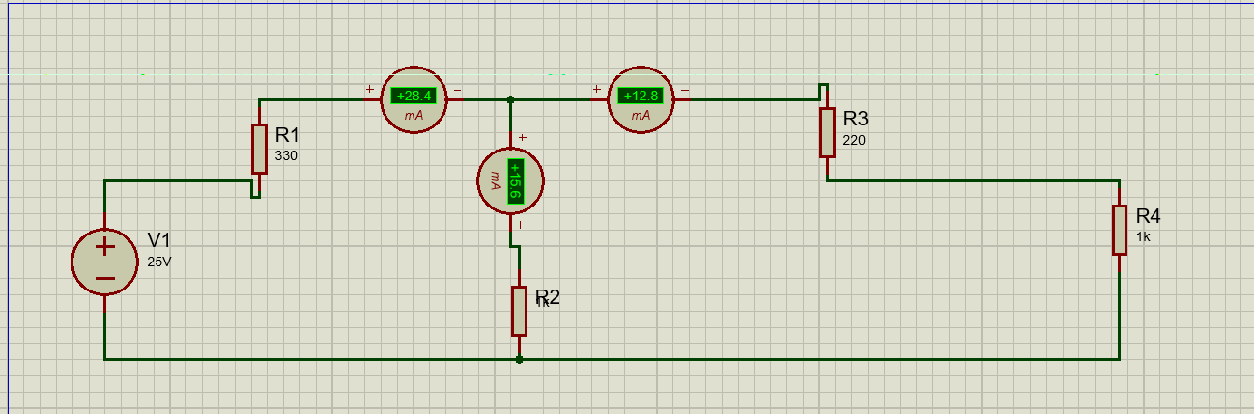

Experiment 2: Verifying Kirchhoff’s Voltage Law (KVL)
How I Built the Circuit: For the second experiment, I needed to prove that the sum of the voltage drops in a closed loop equals the total supplied voltage (E1 = V1 + V2). I used the same VSOURCE and RES components from my library.
I started by placing the battery on the left. Then, I placed three resistors: a 330Ω resistor horizontally at the top, a 1kΩ resistor placed vertically in the middle, and a 220Ω resistor placed vertically on the right. I wired the 1kΩ and 220Ω resistors in parallel with each other.
Since I needed to measure voltage this time, I selected the DC Voltmeter from the virtual instruments menu. I know that voltmeters must be connected in parallel, so I wired one directly across the 330Ω resistor (V1), one across the 1kΩ resistor (V2), and one across the 220Ω resistor (V3). Finally, I tied the whole circuit to a ground terminal at the bottom.
When I ran the simulation at 5V, 10V, and 15V, the first thing I verified was that V2 and V3 gave the exact same reading, which made perfect sense since they were in parallel. Then, I added the voltage drop from the first resistor (V1) to the voltage drop of the parallel section (V2). The total mathematically matched the battery voltage every single time, proving that KVL holds true in the circuit.

